Scope of Work for Tax Map Key (TMK): (1) 9-1-017:158 Kapolei Lot
The table below contains the State’s current estimate of the schedule and significant dates. All times are Hawaii Standard Time (HST). If a component of this schedule, such as "Bid quotes Due Date and Time" is delayed, the rest of the schedule may likely be shifted by the same number of days. Any change to the IFB Schedule and Significant Dates prior to the bid quote due date shall be issued by addendum.
Event | Date
Solicitation Release: | 7/20/2026
Question Submittal Deadline: | 7/27/2026, 4:00 P.M.
Answers to Questions: | 7/28/2026, 4:00 P.M.
Bid quote Due Date and Time: | 7/30/2026, 2:00 P.M.
Evaluations | 7/30/2026 – 7/31/2026
Estimated Date for Discussions, if necessary | TBD
Estimated Due Date for BAFO, if necessary | TBD
Anticipated Award Date: | 7/31/2026 2:00 P.M.

*Supporting documentation must be either uploaded to HIePRO or submitted to darlene.bryant@hawaii.gov.
A. SCOPE OF WORK (SOW)
Item 1: Cut and remove all vegetation to ground surface level within a thirty (30) foot wide strip of land along the northern boundary fence line (along Keahumoa Parkway) and the eastern boundary fence line (along Ko’oloa’ula Housing Development) as shown Exhibit D. All trees within the strip of land shall be cut leaving a stump no higher than three (3) inches.
Removal of trunks, trimmings, vegetation, and debris shall be hauled away the day of the cut/removal and disposed of off-site and at an authorized facility.
State of Hawaii registered herbicide(s) shall be applied to the freshly cut surface of the remaining portion of the woody stump. Recommended for cut surface treatment of the remaining portion of the stump is a mixture of 25% Garlon®, 1% Milestone® mix, in crop oil with blue color dye marker. However, alternative herbicide solutions may be applied that are considered effective. Alternative herbicide solutions must be preapproved by ODLO first. All herbicide applications shall be conducted in compliance with all Federal and State laws and regulations and label directions. The applicator shall be solely responsible for the application efficacy, control and any off-target damage caused by any herbicide application.
Item 2: Conduct two (2) vegetation maintenance clearing within the thirty (30) foot wide strip to begin at six (6) month intervals after work is completed satisfactorily. Maintenance will be conducted in the same area of the lot with the same scope of work as Item 1.
Also, due to the dry nature of the vegetation and surrounding area, all precautions shall be taken to prevent fires due to any sparks from machinery. It will be mandatory to have a fire extinguisher or water tank on all equipment in case of fire. The thirty (30) foot strip of land was originally lined with gravel therefore, the work shall be done manually to avoid sparking or use of other methods that will not cause fire.
B. GENERAL NOTES:
- All work shall be done between 8:00 a.m. to 4:30 p.m., Monday through Friday (excluding State holidays) except with the prior approval of ODLO.
- The Contractor shall be responsible for verifying the location of all utilities and structures. Any damage, injury, and/or loss to any property resulting from the performance of the work shall be the sole responsibility of the Contractor, and shall be remedied promptly by the Contractor at his own expense.
- The Contractor will be provided contact information for the sites to coordinate physical access to the site, if needed.
- The Contractor shall provide safety signs, barricade, and other devices necessary for the safety and convenience of the general public.
- The Contractor shall observe all applicable Federal, State, and Municipal acts, statutes, ordinance, and rules pertaining to the performance of this job.
- The bid award shall be based on the availability of funds.
- Submission of bid shall be the evidence that the Contractor understands the scope of the job described herein.
- If erosion and sediment control measures are needed, they will be in place
C. MAP OF AREA: C1-C2
TAX MAP KEY: (1) 9-1-017:158
C1
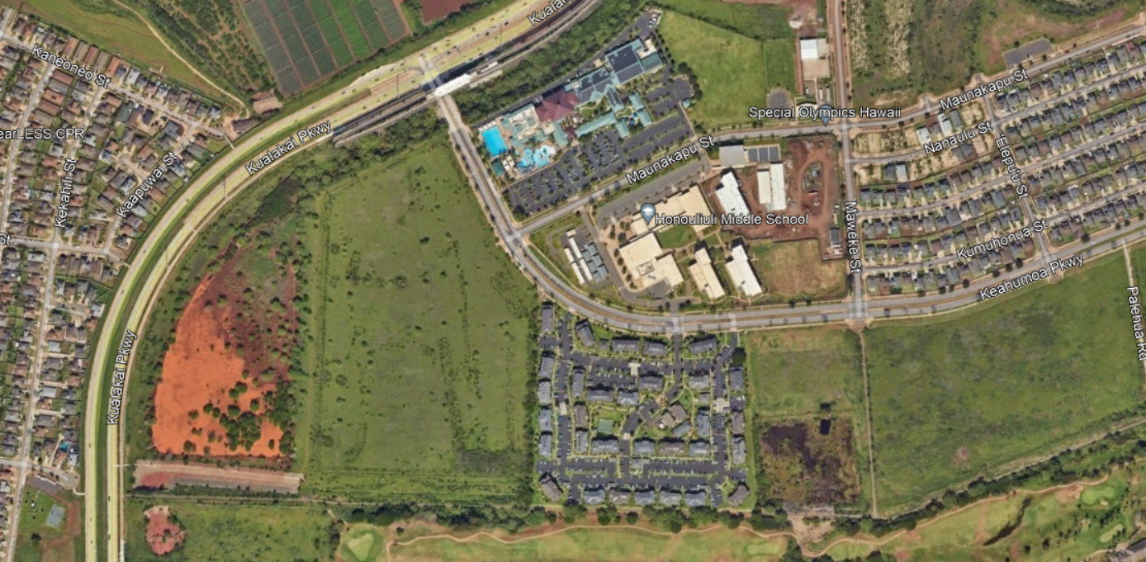
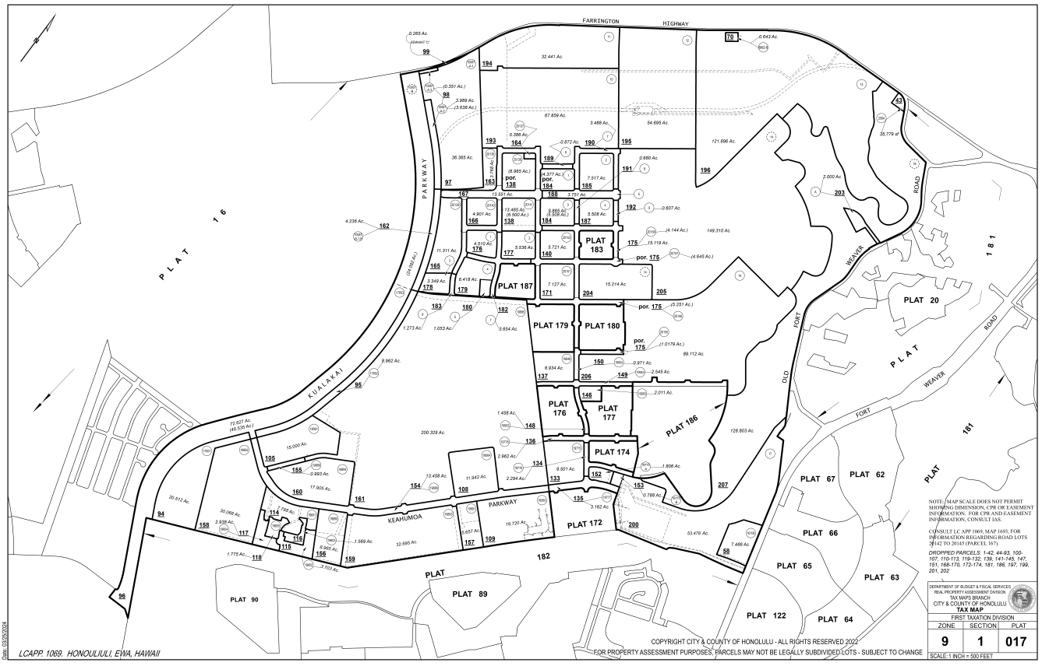
Subject area

TAX MAP KEY: (1) 9-1-017:158
C2
